Ralph Kimball is known as the “Father of Business Intelligence” for defining the concept behind “Data Marts”. He published a lot of best-selling books, such as *The Data Warehouse Toolkit*, *The Data Warehouse Lifecycle Toolkit*, *The Data Warehouse ETL Toolkit* and so on. In these books, Kimball systematically discussed that data warehouses must be designed to be understandable and fast. His methodology, also known as dimensional modeling or the Kimball methodology, has become the de facto standard in the area of decision support.

Ralph Kimball was born in 1944. He received a PH.D. in 1973 from Stanford University in electrical engineering. The specialization was man-machine systems. After that, Ralph worked at Metaphor and founded Red Brick Systems. Worth mentioning at that time was Ralph co-invented the first commercially-available workstation with a graphical user interface at Xerox’s Palo Alto Research Center (PARC)1.

Since 1992, Ralph Kimball has been designing data warehouse systems and teaching dimensional data warehouse design. As a pioneer in this field, Kimball published *The Data Warehouse Toolkit* in 1996 and invent the dimensional approach. In 2002, Kimball updated book and defined multiple databases called data marts which were organized by business processes, but used enterprise standard data bus –the bottom-up approach.

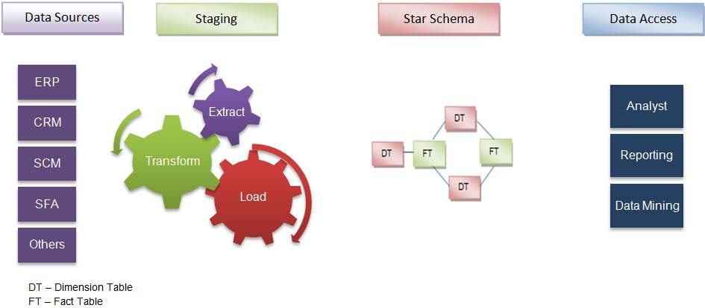

So, what is dimensional modeling? In *The Data Warehouse Toolkit*, Kimball thinks that dimensional modeling is a design technique for databases intended to support end-user queries in a data warehouse. It is oriented around understandability and performance2.

In this modeling, there are two very important concepts, facts (measures) and dimensions (context). Facts are usually typically numeric values that can be aggregated, and dimensions are groups of hierarchies and descriptors that define the facts. For example, sales amount is a fact; product, register No. and store No. are elements of dimensions.

The dimensional model is built on a star-like schema, with dimensions surrounding the fact table. To build the schema, the following design model is used:

1. Choose the business process
2. Declare the grain
3. Identify the dimensions
4. Identify the fact

Dimensional normalization or snowflaking removes redundant attributes, which are known in the normal flatten de-normalized dimensions. Dimensions are strictly joined together in sub dimensions.

Snowflaking has an influence on the data structure that differs from many philosophies of data warehouses. Single data (fact) table surrounded by multiple descriptive (dimension) tables.

In brief, Kimball’s modeling requires the design is the data marts facilitating reports and analysis are created first; these are then combined together to create a broad data warehouse. Kimball defines data warehouse as “A copy of transaction data specifically structured for query and analysis”3.

Ralph Kimball and Bill Inmon have different thought to build data warehouse. However, these two person form the philosophy in this field.

Site References:

1. Joshua Burkhow, “The Father of Dimensional Modeling: Ralph Kimball”, July 19, 2011, <http://www.dataenthusiast.com/2011/07/ralph-kimball/>
2. Ralph Kimball, “The Data Warehouse Toolkit”
3. Sansu George, “Inmon vs. Kimball: Which approach is suitable for your data warehouse?”, <http://searchbusinessintelligence.techtarget.in/tip/Inmon-vs-Kimball-Which-approach-is-suitable-for-your-data-warehouse>